Blacksburg United Methodist Church
111 Church Street
540 - 552 - 5424

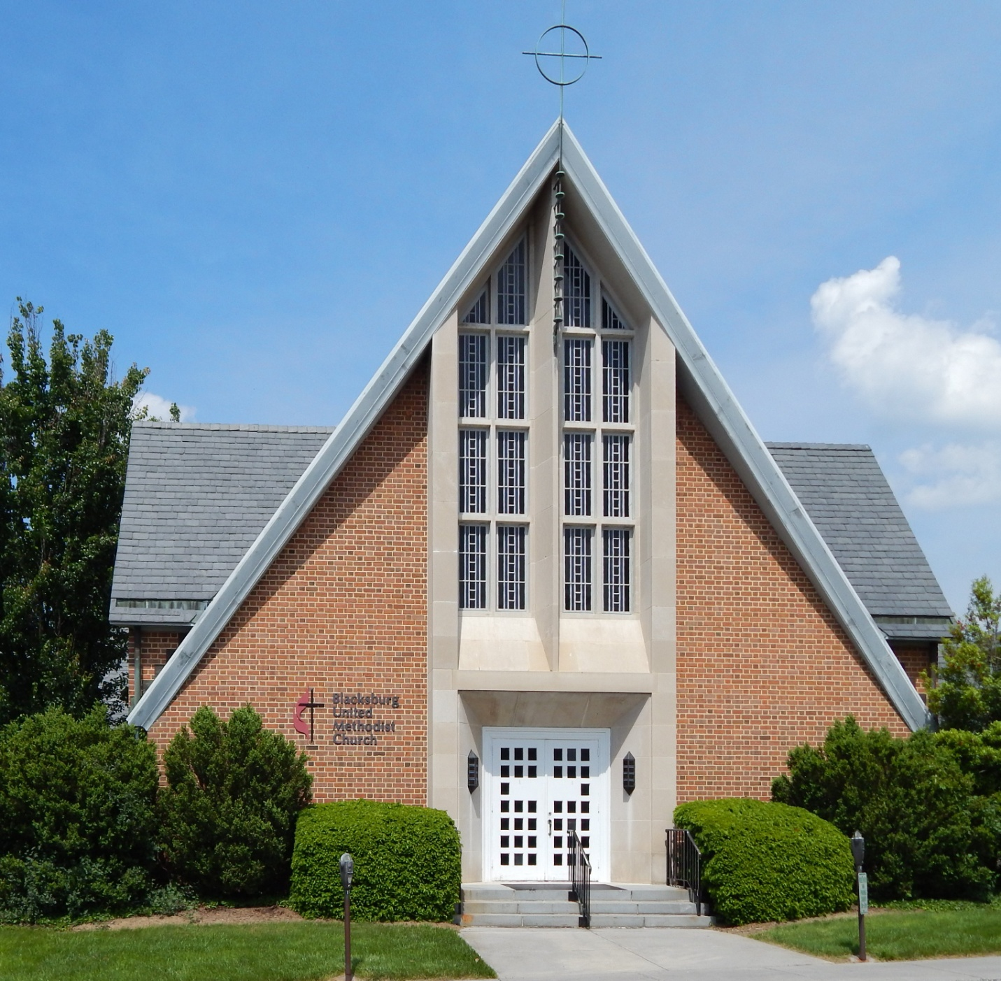
The Blacksburg United Methodist Church was founded in 1783 and grew out of the "Methodist Society" that was started earlier by Joseph McDonald, a local businessman. While in Philadelphia near the start of the Revolutionary War, McDonald heard preaching by Bishop Francis Asbury, who worked to introduce Methodism to the United States. McDonald returned to the Blacksburg area and organized the Society. At first the Methodists depended on Circuit Riders (ministers who traveled by horseback over fairly long distances to preach at a circuit of churches), with local people filling in when Circuit Riders were not available. The date of the church founding is based on the sermon of the first requested minister. The church was formally organized in 1830.
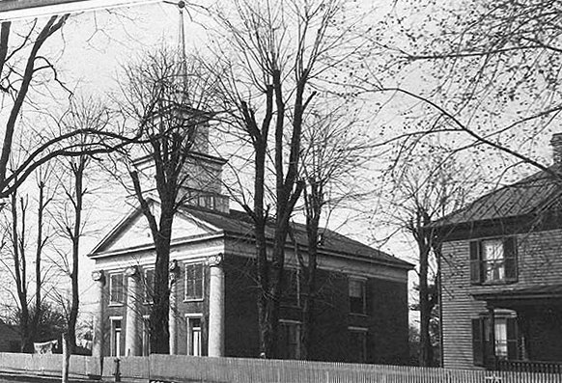
The Methodist Church of 1846
Courtesy of Special Collections, University Libraries, Virginia Tech

When the Town of Blacksburg was laid out by William Black, a lot was designated for a Methodist Meeting House, and a small log structure was built on the site. For several years, the local Presbyterians shared this Meeting House with the Methodists. Later, the Presbyterians bought the Meeting House and replaced it with the Presbyterian Parsonage.
The original building was succeeded by four other buildings, all on the same lot. The second building, put up in 1830, was a larger log house which was consecrated as the first official Methodist Church. In 1846 a brick church was constructed. This building had the largest auditorium in Blacksburg and was used for college graduation exercises.
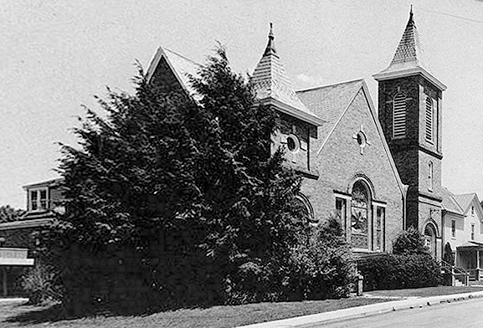
The Whisner Memorial Church of 1906
Courtesy of Special Collections,
University Libraries, Virginia Tech

Fifty years later it was found that the walls of the brick building were deteriorating, so in 1906 a new brick church was built, named after a former pastor P. H. Whisner. Tiffany memorial windows in the Whisner Memorial Church were installed for less than $2000 (approximately $52,000 in year 2000 money). In 1955 the current building was constructed, and the Whisner Building was remodeled for general purposes.

n 1851 the Blacksburg Methodist Church helped to found the Olin and Preston Institute in Blacksburg as a Methodist college. After the Civil War technical financial difficulties caused the college to change the name to the Preston and Olin Institute. Life in the South was difficult during this time, and the college remained in serious financial trouble. Members of the Methodist Church, led by Whisner and Harvey Black, appealed to the state legislature to convert the institute into a land-grant college. In 1872 it was re-chartered as the Virginia Agricultural and Mechanical College, which gradually evolved into Virginia Tech. Eventually the college brought a large number of students to Blacksburg, many of whom attended local church services. The student population is one of the main reasons for the increase in church buildings in the 1870's and later.
Before the Civil War, it was common for African-Americans to attend services in mostly white churches. We know that both the Methodist and Presbyterian Churches had African-American members, some slave, some free. At that time it was illegal in Virginia for slaves to assemble for worship unless they were under the supervision of a white preacher. In most churches African-Americans were required to sit in the balcony during services while the white members sat in the pews below. For example, the Methodist Church of 1846 had a balcony specifically designated for the "colored" members. Here is a quote from the article by the Rev. Christopher Donald in the Smithfield Review:
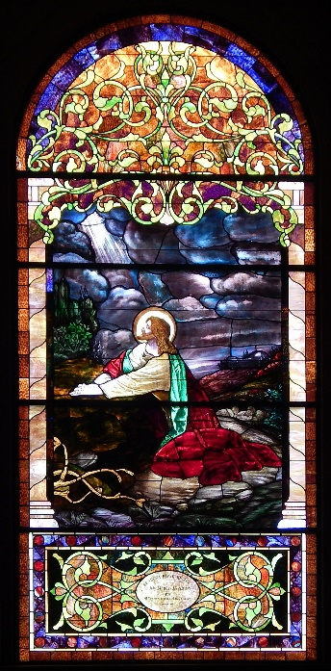
Tiffany Window in
Whisner Building

As I looked through these records, I noticed that several members baptized or married in the last 1850s and early 1860s had the notation “colored” beside their names. Between 1862 and 1864, twenty-three white probationers and nineteen African-American probationers were listed. At that time, the Methodist denomination required a six-month probationary period of its prospective members before they were granted full membership in the church. In fact, whole class lists of African-Americans were recorded; of the five classes meeting at the church, two were wholly African-American. In 1860, Blacksburg Methodist Episcopal Church, South (MECS) had 142 members; forty-eight of those members were African-American. In less than fifteen years, however, all 180 members of the church were white. The African-American members of Blacksburg MECS had disappeared from the membership and class rolls.
We think that the black members left to form the St. Paul AME church.

Sources

Donald, Christopher, "Growth and Independence of Methodist Congregations in Blacksburg,
A Virginia Town," Smithfield Review, Volume X. 2006.

Harrison, Charles H., The Story of a Consecrated Life, Commemorative of Rev. Charles S. Schaeffer, Brevet-Captain U. S. V., J. B. Lippincott Company, Philadelphia. 1900. This book is available for reading on-line at http://archive.org/details/storyofconsecrat00harr.

Raboteau, Albert J., Slave Religion, Oxford University Press, New York. 1978.

