Luther Memorial Lutheran Church
Corner of Toms Creek and Prices Fork Roads
552-0066
www.lmlc.org/
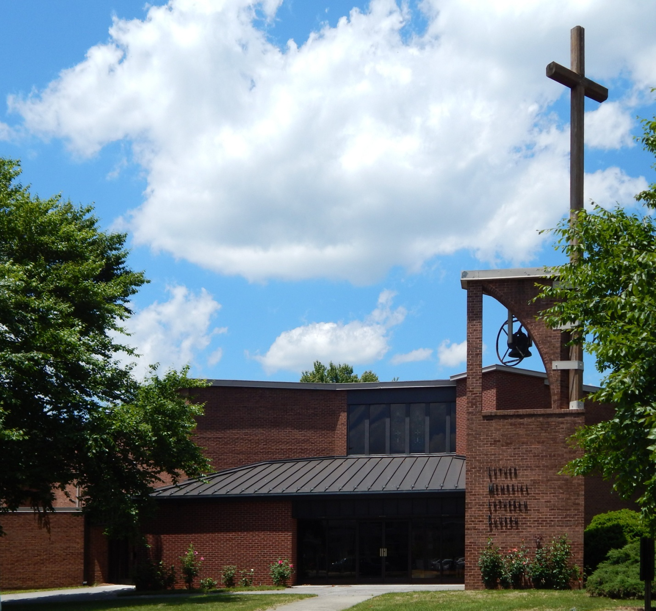

Luther Memorial Lutheran Church was officially organized in 1886, but preliminary work had been done earlier. The church was founded by older congregations to minister to the students in the Corps of Cadets in the new Agricultural and Mechanical College. It is a direct descendant of St. Michael's/St. Peter's Lutheran Church, which was on the boundary of present-day Blacksburg towards Price's Fork and the site of the current St. Michael Lutheran Church.
The church building was started in 1883, on Turner Street where the McDonald's restaurant is now located. It was constructed of hand-made bricks formed on-site and fired on a temporary kiln. When that building was torn down in the 1970s for the move to the current church building, many of the bricks were salvaged, cleaned by hand by church members, and used to build the altar table and pulpit of the present church.
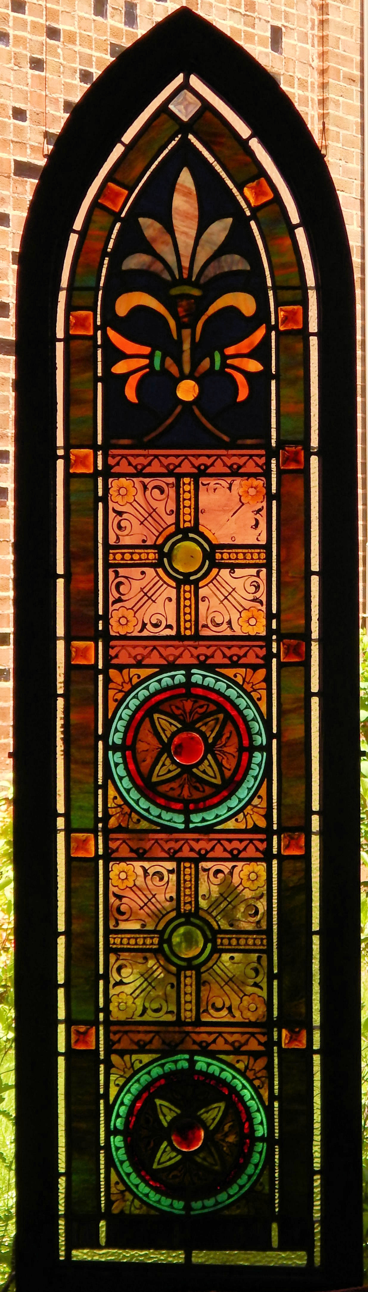
Stained Glass Window from Church of 1883

Stained Glass Window from Church of 1883
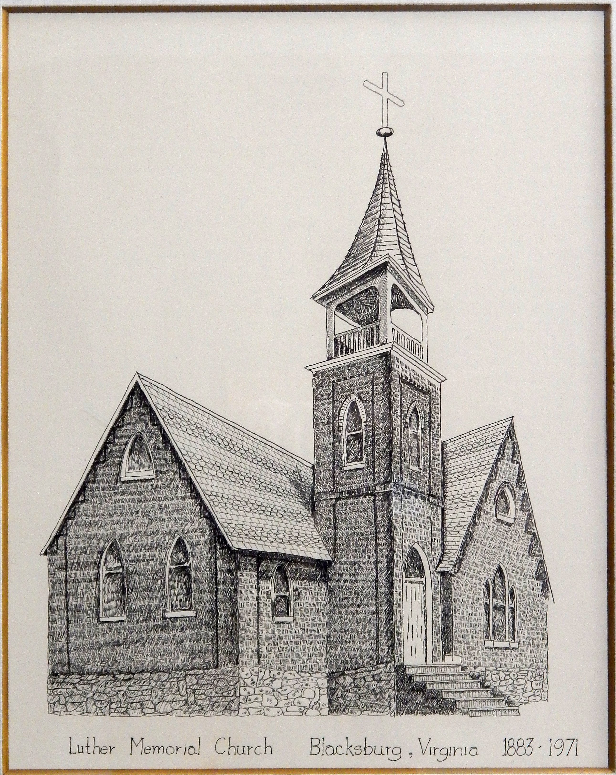
Luther Memorial Church of 1883

Sources:

Bodell, Dorothy H., "Social Life and Customs," Blacksburg, A Special Place for 200 Years, Clara B. Cox, ed. Town of Blacksburg. 1998.
Eisenberg, William Edward, The Lutheran Church in Virginia 1717 - 1962. Trustees of the Virginia Synod, Lutheran Church in America, Roanoke, Virginia. 1967.
Web Site: http://www.st-michael-lutheran-church.org/about-us/history/a-legacy-of-ministry/

