Christ Episcopal Church
120 Church Street, NE
552-2411
Web Site: christchurchblacksburg.org

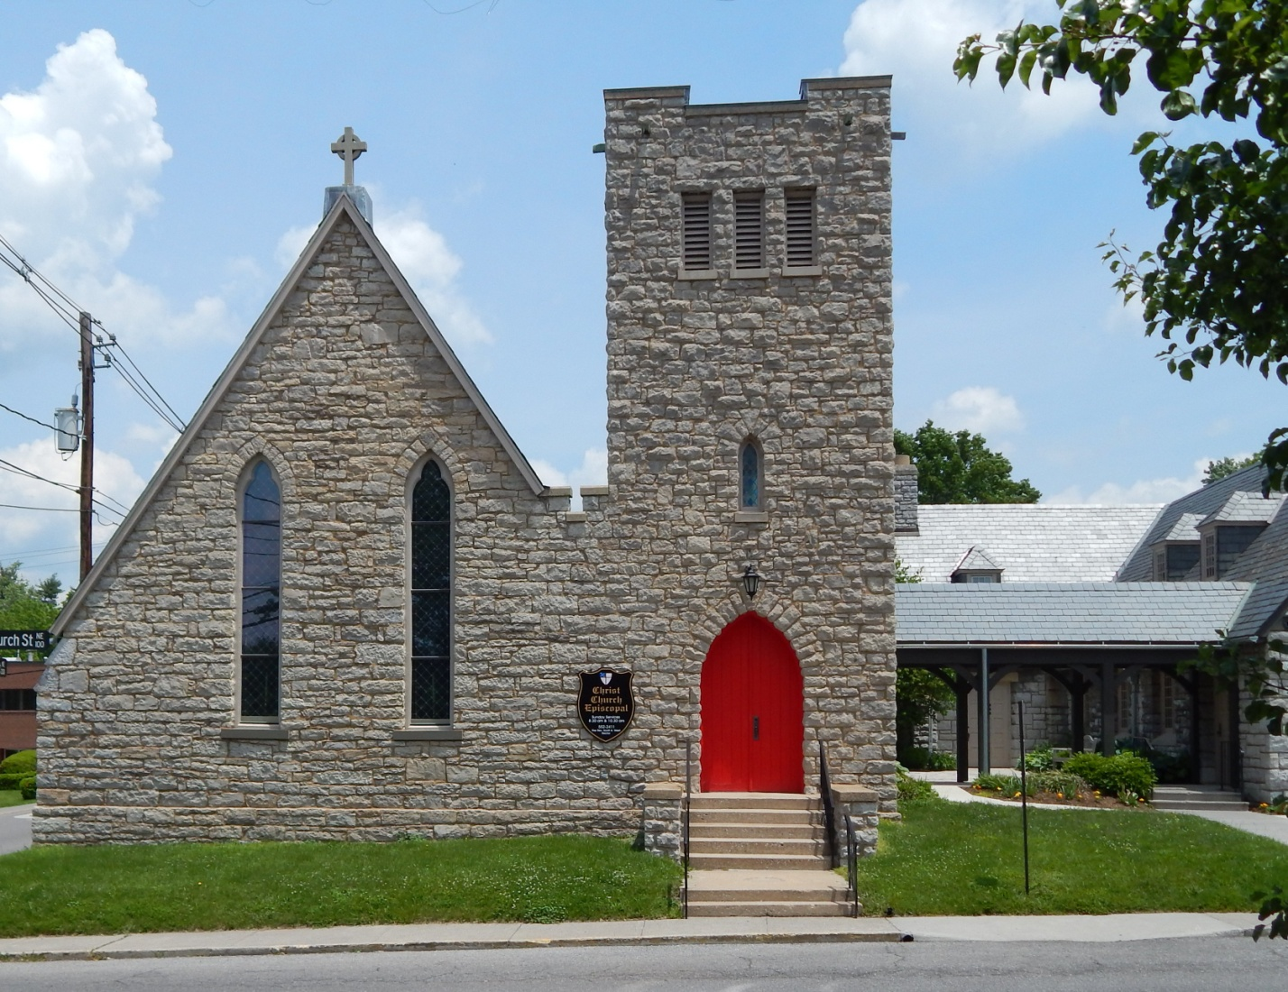

Christ Episcopal Church is the only historic church within the original Sixteen Squares of Blacksburg that meets in its original church building.

Church of England parishes were established within counties when the counties were created in colonial Virginia. Montgomery County and Montgomery Parish were established simultaneously in 1777 by an act of the General Assembly. The Church of England was the established church for colonial Virginia, and religious groups outside the scope of Anglicanism were rarely tolerated. The colony’s citizens were obligated by law to attend their local parish church, to be baptized, married, and buried by an Anglican priest, and to support the parish with their tithes. A parish vestry, the parish’s governing body comprised of local male landholders, served in essence as the county government and had the responsibilities for building and maintaining roads, paying for the care of the poor, paying for the burial of the indigent dead, building and maintaining church buildings, collecting the tithes (that is, the tax every landholder was obligated to pay), and paying the clergy. Clergy serving the church in Virginia had been ordained in England and at their ordination vowed obedience to the king. The ties between the Anglican Church in Virginia and England were strong. The system broke down during the Revolutionary War. Technically the Montgomery Parish existed, but was on the western frontier with a sparse population. Efforts to found an Anglican congregation in what is now Blacksburg were stymied.

The Protestant Episcopal Church in the United States of America was created in 1785 out of colonial Anglican churches. At the same time the Episcopal Diocese of Virginia was established along with other dioceses in the states along the eastern seaboard. The newly formed Episcopal Church found itself in dire straits following the Revolutionary War. The Commonwealth of Virginia passed Acts of Disestablishment, seized church property, and sold church silver. The number of clergy diminished not only out of their loyalty to the English crown, but because the Commonwealth had seized the glebes or farms on which they lived. The Episcopal Church in Virginia was at its lowest ebb in the very early 19th century.
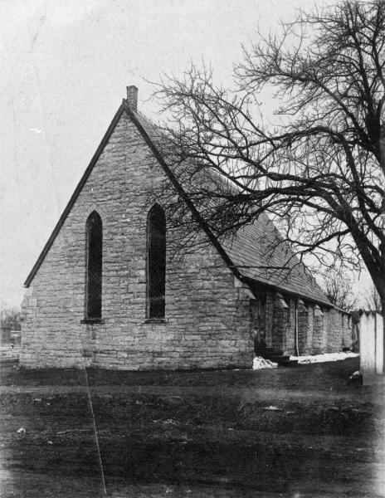
Early Picture of Christ Episcopal Church
Courtesy of Special Collections, University Libraries, Virginia Tech
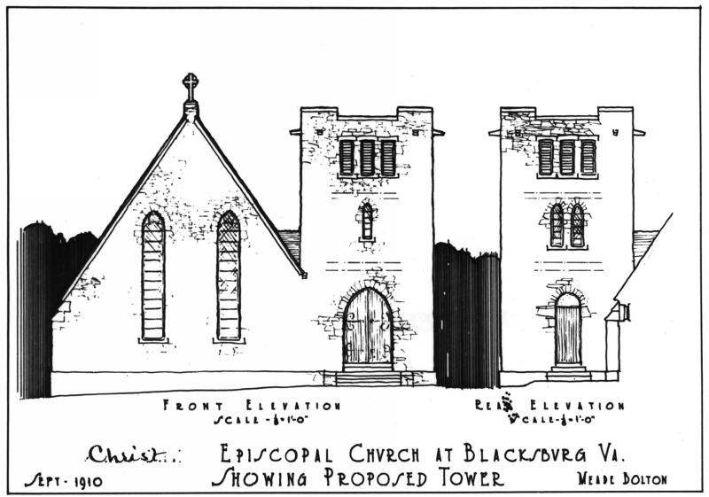
Architect Drawing From 1910 Showing the Plan for a New Church Bell Tower, Built in 1934
Courtesy of Special Collections, University Libraries, Virginia Tech
Many of the early English-speaking settlers in the Blacksburg area were Methodists and Presbyterians, groups that had been discriminated against by the Church of England, and most were hostile to the newly established Episcopal Church.

It wasn’t until the 1840s and 1850s that serious missionary efforts were made to establish Episcopal churches west of the Blue Ridge Mountains.

Christ Church was founded in 1858 largely due to the work of a missionary priest of the Diocese of Virginia who served Montgomery, Wythe, Tazewell, and Smyth Counties along a small number of individuals interested in establishing an Episcopal Church in Blacksburg. Members of the Preston family of Smithfield were instrumental in this effort. The building of a church edifice was delayed by the Civil War, but by 1874 the present Christ Church was under construction. The first service was held in March 1875, and the church building was consecrated on September 25, 1887.

The original Montgomery Parish, established by colonial county lines, has been subdivided four times since its creation; Wythe Parish was created in 1846, Pulaski Parish in 1878, Radford Parish in 1891, and St. Thomas Parish in 1898.

Christ Church has been added to over the years. In 2011-2012, the exterior of the church building was restored to its original appearance. The sanctuary of Christ Church remains remarkably similar to the original with the exceptions of added brass lectern and pulpit, an altar that replaced the original communion table, and repositioning of organ pipes.

Sources

Bond, Edward L. and Joan R. Gundersen. The Episcopal Church in Virginia, 1607 – 2007.
Richmond, Va.: The Episcopal Diocese of Virginia, 2007.

Brown, Katherine L. Hills of the Lord: Background of the Episcopal Church in Southwestern Virginia, 1738 – 1938. Roanoke, Va.: The Diocese of Southwestern Virginia, 1979.

Christ Church, Blacksburg, Va. Historic Papers and Photographs Collection.

Cocke, Charles Francis. Parish Lines Diocese of Southwestern Virginia. Richmond, Va.: The Virginia State Library, 1960, reprinted in 1980.

Diocese of Virginia Annual Convention and Annual Council Journals, 1856 – 1892.

Prichard, Robert. A History of the Episcopal Church. Harrisburg, Pa.: Morehouse Publishing, Inc. 1991.

http://www.christchurchblacksburg.org/history.shtml

