Blacksburg Baptist Church
550 North Main Street
540 - 552 - 3905
blacksburgbaptist.org
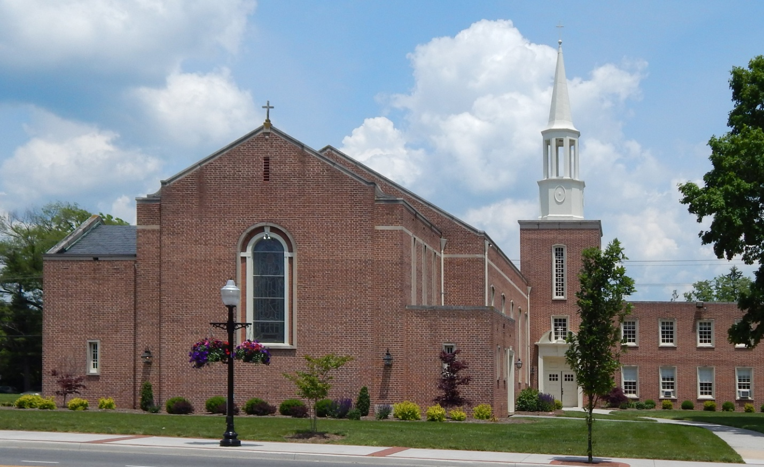

In the early nineteenth century a second religious "Great Awakening" swept the country and reached the New River Valley. This was accompanied by tent meetings and revivals which influenced people to turn from their wicked ways to a more active religious life. The main recipients of this awakening were the Methodists and Baptists.
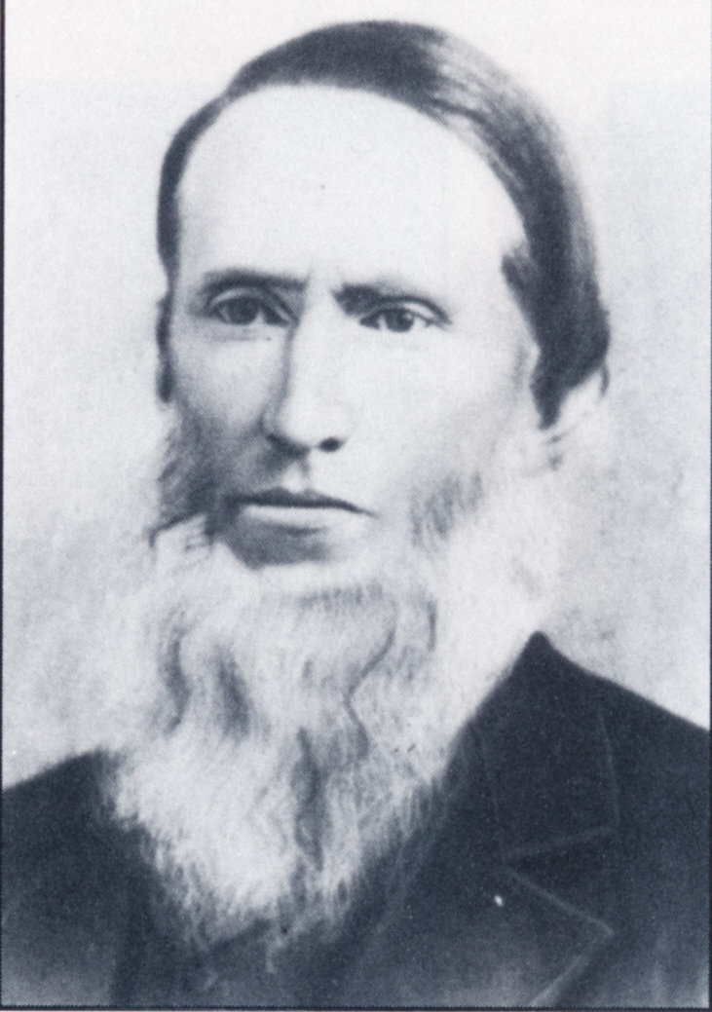

James Monroe Evans, a cabinet maker, started Blacksburg Baptist Church in his home in 1845

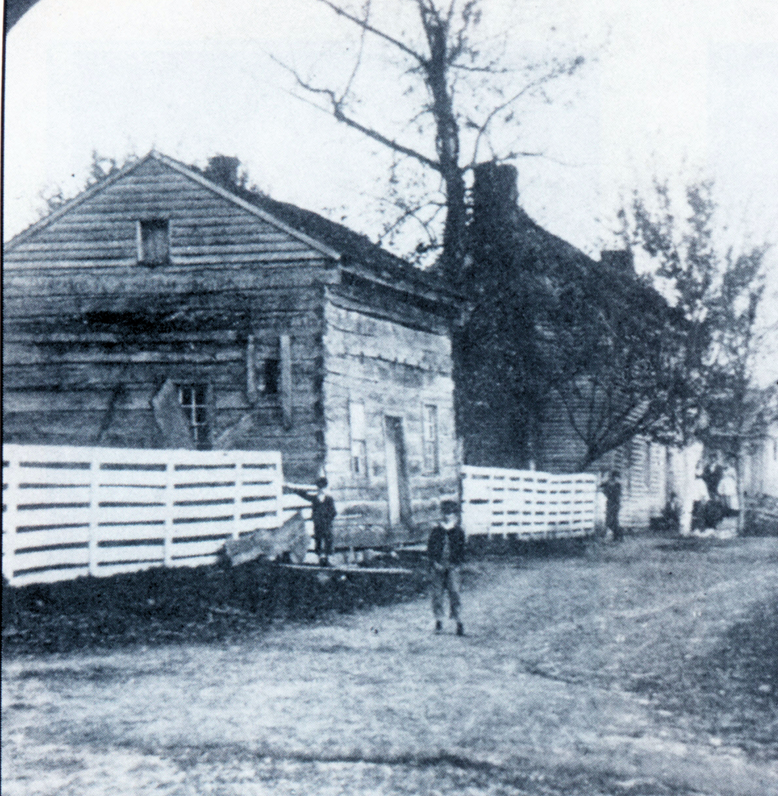

Home of James Monroe Evans
At first the Blacksburg area Baptists worshiped in private homes, but in 1852 they organized their first church - the third oldest church in Blacksburg. In that year the newly constituted church was admitted as a member of the Valley Baptist Association with seventeen charter members.

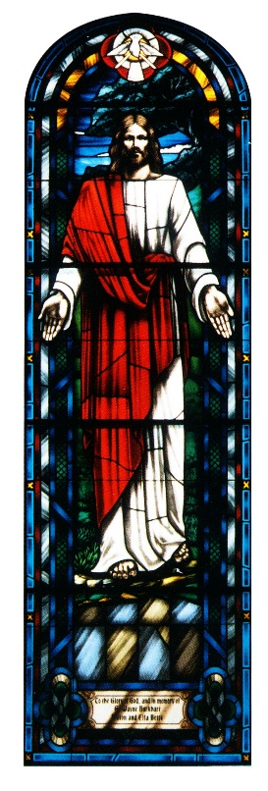
Soon after the church was organized, a building was started on the corner of Roanoke and Church streets, but it was never completed. Eventually it was condemned and destroyed. Sometime after the Civil War, the first Baptist church was built on the same site. In 1903 a second church building was erected on that site, but it was found to be inadequate for the increasing size of the congregation. That building soon was sold to the Blacksburg Christian Church (Disciples of Christ) and the Baptist congregation built a new brick church on the corner of Roanoke and Water (Draper) streets. In 1953 this building was sold to the Blacksburg Church of God, and the current church building was constructed and occupied. (The original church site is now occupied by the Blacksburg Jewish Community Center. The original Church of God building burned in 1958 and that site is now occupied by the Seven-Eleven store.)
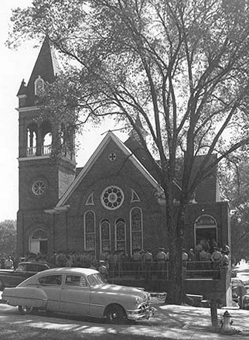
The Third Church Building of the
Baptists at the Corner of Roanoke and Draper Streets
Courtesy of Special Collections, University Libraries, Virginia Tech

Sources:

Bodell, Dorothy H., "Social Life and Customs," Blacksburg, A Special Place for 200 Years, Clara B. Cox, ed. Town of Blacksburg. 1998.

Dunay, Donna, et al, Blacksburg, Understanding a Virginia Town. Penn Washington. 1986.
Massey, James C., The Church on Main Street: A History of the Blacksburg Baptist Church. Blacksburg Baptist Church. Blacksburg, Va. 1995.

Taylor, Charles Lewis, What Mean These Stones? A History of the Blacksburg Presbyterian Church. Blacksburg Presbyterian Church. Blacksburg, Virginia. 2013.
Web Site: http://www.blacksburgbaptist.org/

